IDE SET-UP AND LIB INSTALLATION
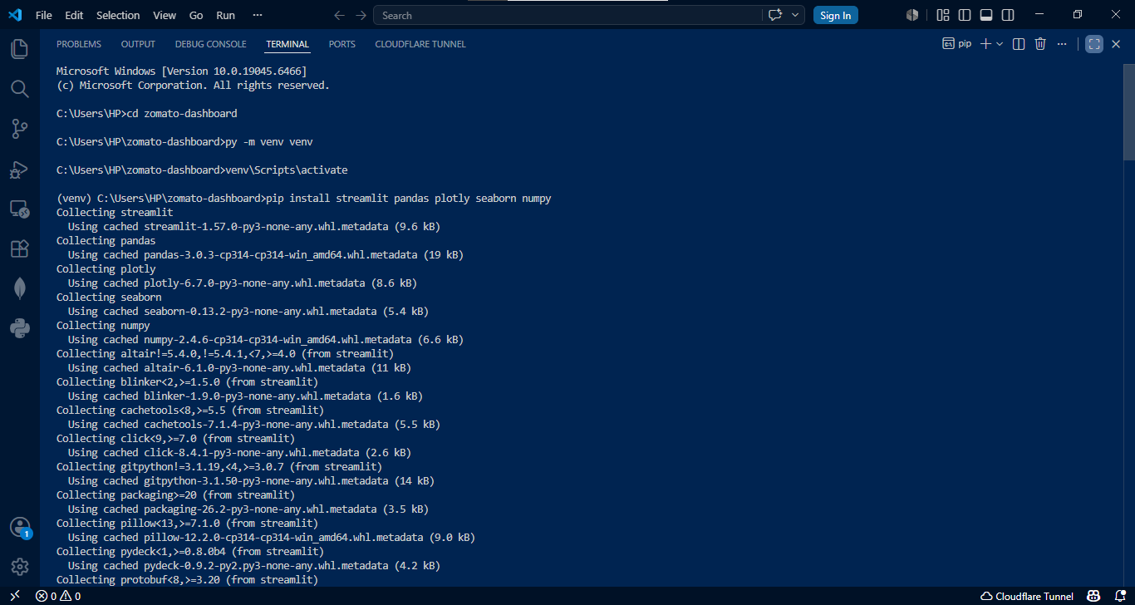
DATA CLEANING
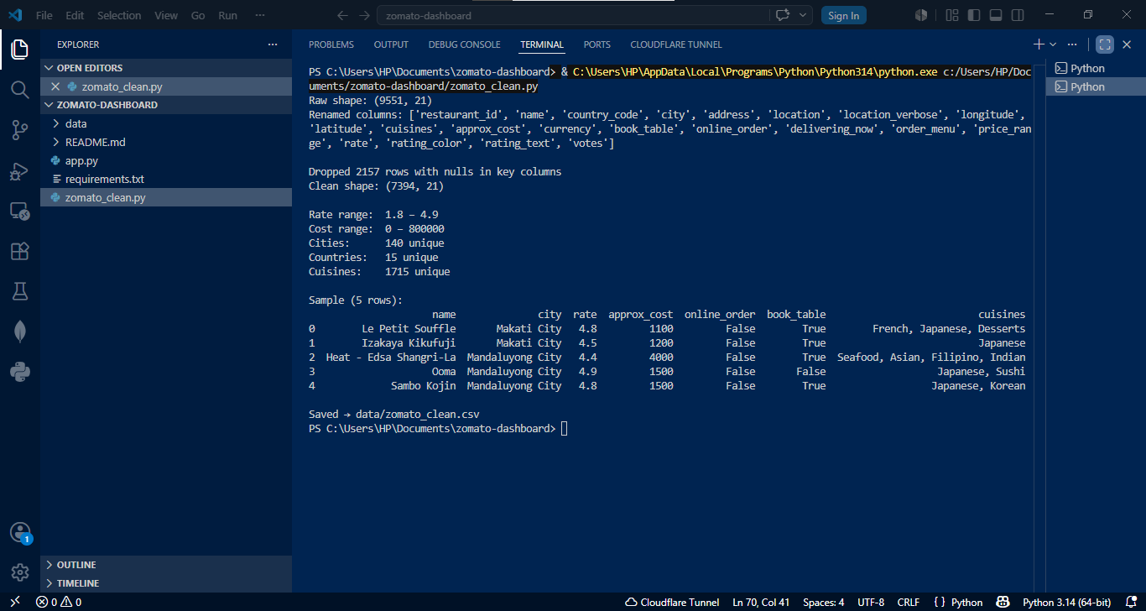
TOP 10 CITIES
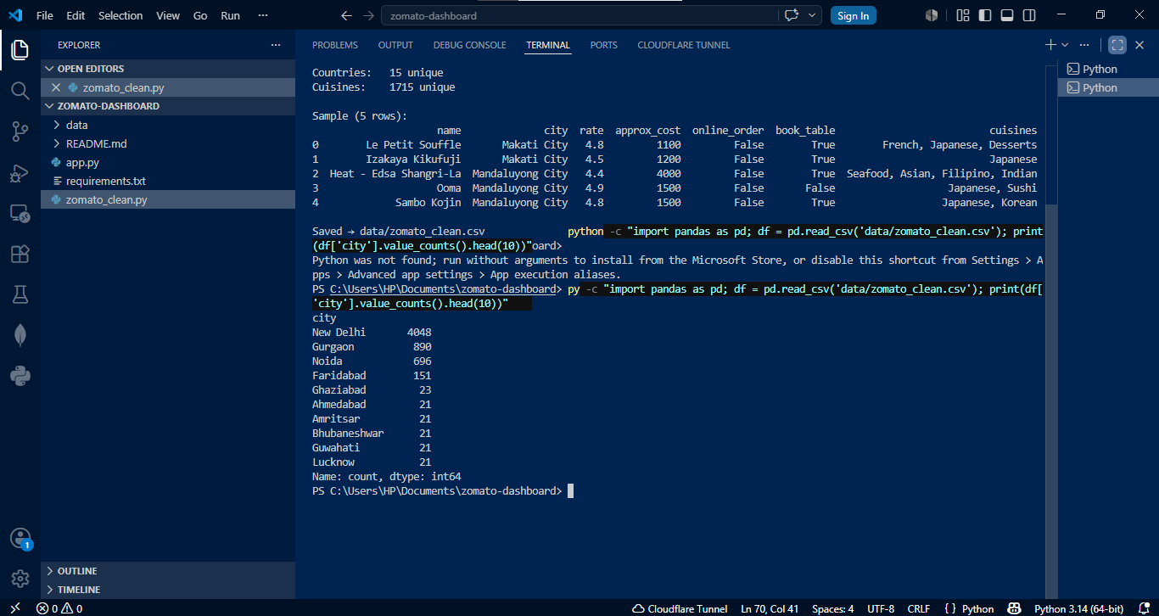
ROWS AND COLUMNS
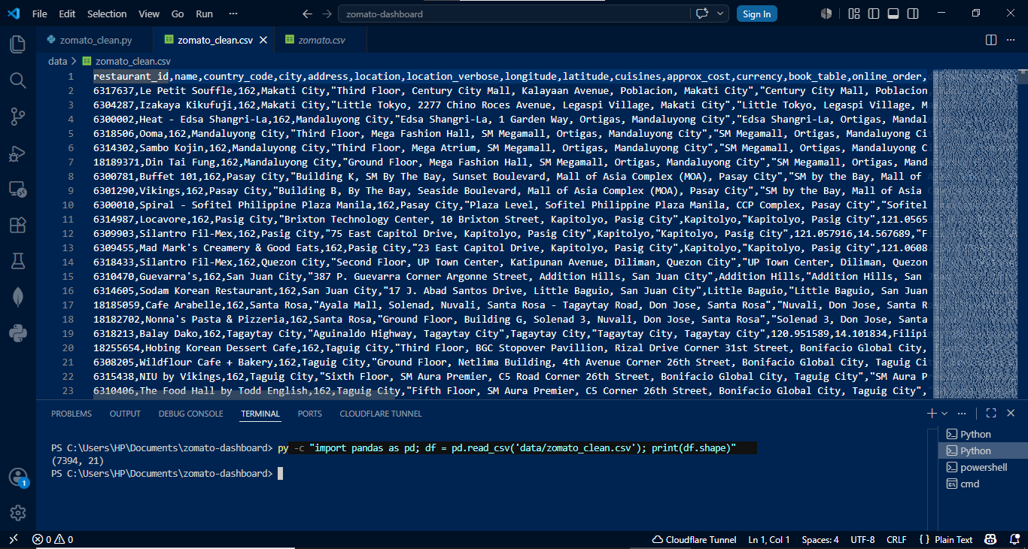
COUNTRY CODE
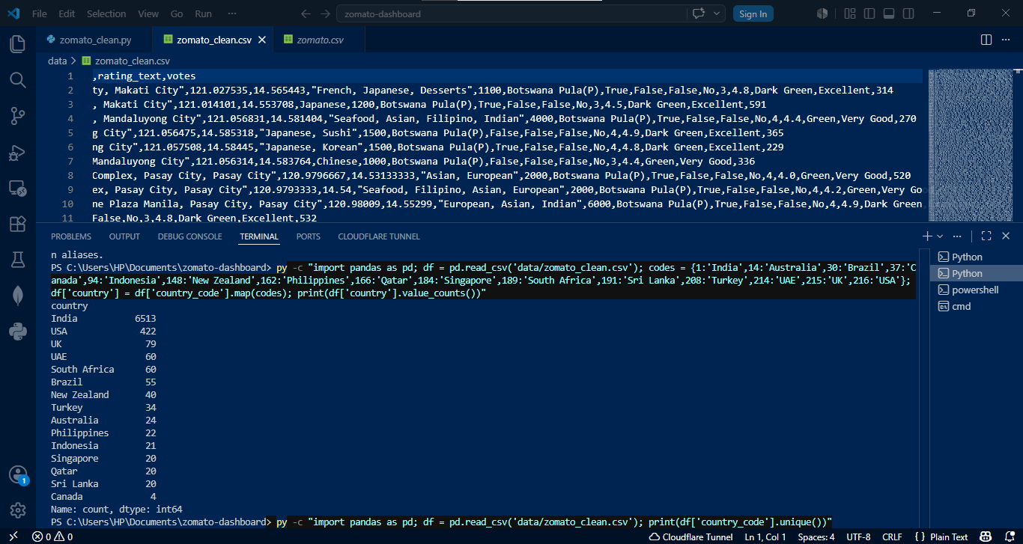
CORR B/W COST AND FOOD QUALITY ALONG WITH SCATTER PLOT
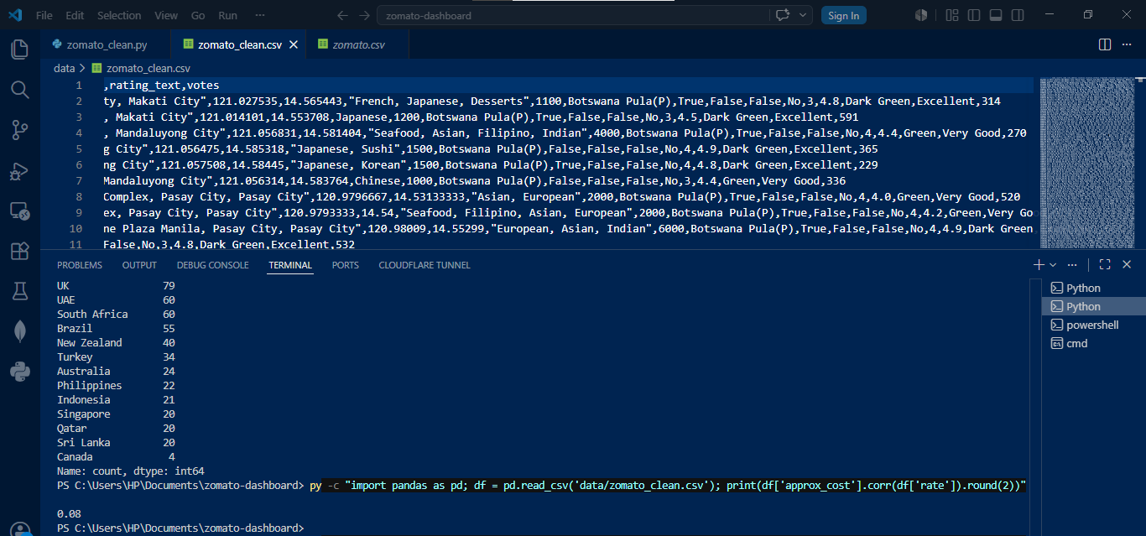
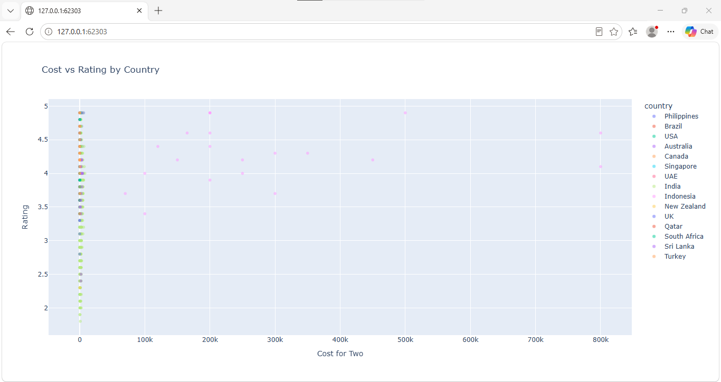
ONLINE DELIVERY EFFECTS VS DINE IN

RESTAURANTS WITHOUT TABLE BOOKING

